Anglais: dossier de révisions

Introduction
- Ecris les nombres en lettres. Attention à l’orthographe!
3 =
15 =
84 =
398 =
671 =
Unit 1: Check up
- Etre: conjugue le verbe à toutes les personnes. Donne la forme positive et négative.

- Avoir: conjugue le verbe à toutes les personnes. Donne la forme positive et la forme négative.

- Ecris les nombres ordinaux en lettres.
3rd ……………………………. 24th ……………………………
9th …………………………….
15th …………………………..
31st …………………………..
- Ecris les dates suivantes en lettres.
3 février ………………………………………
6 avril ………………………………………
12 juillet ………………………………………
15 août ………………………………………
18 octobre ………………………………………
- Ecris les heures en anglais. (Manière normale)
• 9h30
• 5h45
• 3h30
• 1h50
• 2h25
- Ecris les heures suivantes en utilisant l’horloge des 12h. (Abréviations AM-PM)
• 21:30
• 6:45
• 15:55
• 8:00
• 19.10
Unit 2: Parts (1)
- Complète par A ou AN
• ……… good job
• …….. empty bottle
• …….. umbrella
• …….. key
• …….. fridge
- Complète les phrases par this/that/these/those.
• I remember my first day at school. ……….. day was the happiest of my life. (loin)
• ……… coat is really beautiful. (proche)
• Look at …………… children, there on the left. (loin)
• Look at ………….. birds. (proche)
• I love …………. painting. (proche)
- Regarde la phrase ci-dessous. Comment forme-t-on une phrase à l’impératif?
Tighten the nuts
......................... + …………………….
- Remets les mots dans l’ordre afin de former une phrase à l’impératif.
• the / go/ supermarket /to/ !

• the / take / bus / !

• the / raise / with / car /jack / the / .

• car / lower/ the .

• your / write / name / .

Unit 3: Parts (2)
- Conjugue le verbe entre parenthèses au present simple.
• My mother ………………………………. me to school. (to drive-positive)
• We ………………………………. in Birmingham. (to live-negative)
• ……………………….. you ……………………… at home? (to help-positive)
• I ………………………………. very well with my half-sisters. (to get on-negative)
• He ……………………………….playing tennis. (to enjoy-positive)
- Complète les mots-croisés afin de découvrir le 12e mot.
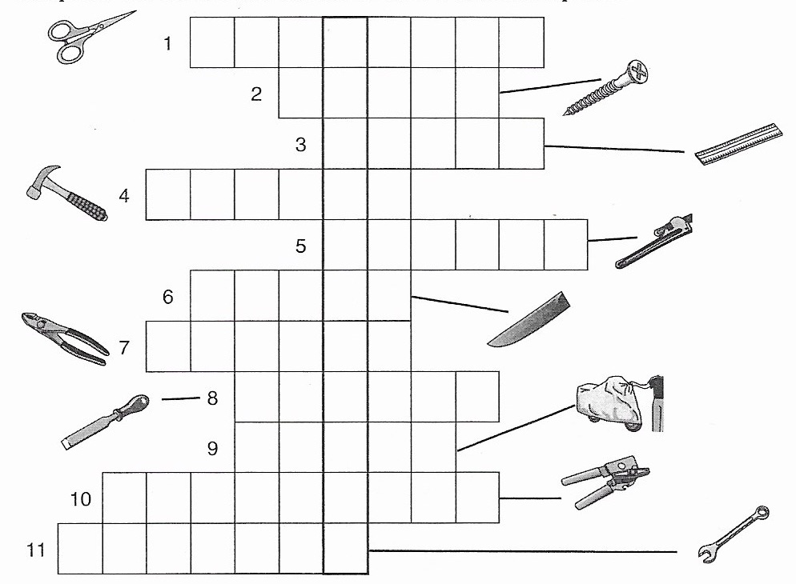

Unit 4: Movement
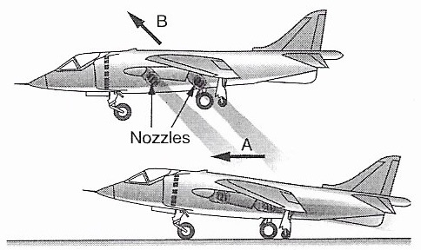
- Regarde la flèche sur chaque photo. Quelle direction représente-t-elle? Note la lettre.

Diagonally up …………
Horizontal …………

- Ecris les formes complètes des vitesses suivantes en lettres.
• 52 km/h ……………………………………………………………………………..
• 78 mph ……………………………………………………………………………..
• 14 m/s ……………………………………………………………………………..
• 283 mph ……………………………………………………………………………..
• 3697 rpm ……………………………………………………………………………..
Unit 5: Flow
- Associe un mot à chaque phrase.
battery cable controller lamp solar panel electrical current switch
• shines a light when the switch is on: ……………………….
• converts the sun’s energy into an electrical current: …………………………….
• stores electricity: ……………………………….
• when a ………………………….. is closed, the electrical current can flow.
• DC is a type of ………………………………….
• electricity passes through the ………………………………... to the lamp or the battery.
• carries the electrical current: …………………………………
to carry = porter, amener
Unit 6: Materials
- Conjugue les verbes entre parenthèses au present continuous.
• I ……………………………… late. (to get up–positive)
• He …………………………… in bed. (to read–negative)
• They ………………………… Algeria. (to visit-positive)
• …………………… she ………………………. in France? (to work-positive)
• You ……………………………... to school on foot. (to go-negative)
Unit 7: Specifications
- Complète les phrases par le nom ou l’adjectif.
• The …………………………….. of the river is 25 metres. (deep/depth)
• The river is 25 metres ……………………………. . (deep/depth)
• The tunnel is 15 kilometres …………………………. . (length/long)
• The …………………………. of the tunnel is 15 kilometres. (length/long)
• This boat has a ……………………………. of 40 metres. (wide/width)
- Complète les phrases par some ou any.
• I must buy ……………… milk.
• Have you got ……………… biscuits?
• I haven’t got ……………… biscuits left.
• I would like ……………… coffee.
• I don’t want ……………… .
- Les phrases ci-dessous sont au futur simple. Si la phrase est positive, mets-la à la négation. Si elle est négative, mets-la à la forme positive.
• There will be two tunnels ……………………………………………………………
• They will finish the tunnel in 2025 ………………………………………………
• The trains won’t use magnetism …………………………………………………..
• There won’t be 200 trains per day ………………………………………………..
• They will build a new tunnel ………………………………………………………
Unit 8: Reporting
- Ecris la forme passée positive et négative de chaque verbe.
Infinitive | Past Simple (+) | Past Simple (-)
To see
To love
To live
To lose
To know

- Conjugue les verbes entre parenthèses au past simple.
• I …………………………… soccer after school last Friday. (to play-positive)
• When ……………… you ……………… your phone? (to buy-positive)
• He ………………………….. a bird fly into the window. (to see-negative)
• The boy ……………………….. that nobody was at home. (to say-positive)
• She …………………………… to the teacher in class. (to listen-negative)
- Expression écrite: regarde les photos et donne des instructions. Utilise l’impératif et les verbes ci-dessous.
close – cut – grip – loosen – measure - open – pull out – put – put on – strike – take off – tighten – use
Example: 1. Use a pair of pliers. Grip the nail.
